**1.2 Data Types**

**Description:** Printing different datatypes

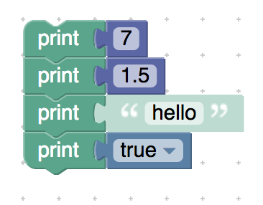

<xml xmlns="http://www.w3.org/1999/xhtml">

 <variables></variables>

 <block type="text_print" id="m{[@,lFs%z0YKIOxj@z-" x="-312" y="-337">

    <value name="TEXT">

     <shadow type="text" id="AsESNowomU.O?]|YfrA.">

       <field name="TEXT">Hello World</field>

     </shadow>

     <block type="math_number" id="L~OG$IcX0zpK;;}^QO?z">

       <field name="NUM">7</field>

     </block>

    </value>

    <next>

     <block type="text_print" id="Zl;b.-B7,rvQcXLv9N-l">

       <value name="TEXT">

         <shadow type="text" id="(T~HpBQ^3i#Y^Q}l8ksQ">

           <field name="TEXT">abc</field>

         </shadow>

         <block type="math_number" id="QHxROMX#C$1Grqt4^+=3">

           <field name="NUM">1.5</field>

         </block>

       </value>

       <next>

         <block type="text_print" id=",OZ_P=Y]08]iuGbPOC.x">

           <value name="TEXT">

             <shadow type="text" id="_Vv}4{P+*BruyWAp^.T%">

               <field name="TEXT">hello</field>

             </shadow>

           </value>

           <next>

             <block type="text_print" id="(pbiIe03?yva3nP8*eE-">

               <value name="TEXT">

                 <shadow type="text" id="]xrc2RqoNVm~8u`FI%Oa">

                   <field name="TEXT">abc</field>

                 </shadow>

                 <block type="logic_boolean" id="-:KxcBpiisN+5_Y{tA2j">

                   <field name="BOOL">TRUE</field>

                 </block>

               </value>

             </block>

           </next>

         </block>

       </next>

     </block>

    </next>

 </block>

</xml>